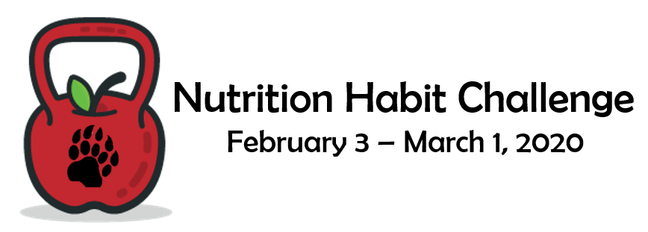

|  |  |  |
| --- | --- | --- |
| **Name:** |  |  |
| **Email Address:** |  |  |
| **Nutritional Commitment:** |  |  |
|  |  |  |
|  |  |  |

**For each day you successfully practice your behavior(s), you receive one point. Record your points in the blank spaces below.**

|  |  |  |  |  |  |  |  |  |
| --- | --- | --- | --- | --- | --- | --- | --- | --- |
| **Week One:** | **Day 1** | **Day 2** | **Day 3** | **Day 4** | **Day 5** | **Day 6** | **Day 7** | **Weekly Total** |
|  |  |  |  |  |  |  |  |  |

|  |  |  |  |  |  |  |  |  |
| --- | --- | --- | --- | --- | --- | --- | --- | --- |
| **Week Two:** | **Day 8** | **Day 9** | **Day 10** | **Day 11** | **Day 12** | **Day 13** | **Day 14** | **Weekly Total** |
|  |  |  |  |  |  |  |  |  |

|  |  |  |  |  |  |  |  |  |
| --- | --- | --- | --- | --- | --- | --- | --- | --- |
| **Week Three:** | **Day 15** | **Day 16** | **Day 17** | **Day 18** | **Day 19** | **Day 20** | **Day 21** | **Weekly Total** |
|  |  |  |  |  |  |  |  |  |

|  |  |  |  |  |  |  |  |  |
| --- | --- | --- | --- | --- | --- | --- | --- | --- |
| **Week Four:** | **Day 22** | **Day 23** | **Day 24** | **Day 25** | **Day 26** | **Day 27** | **Day 28** | **Weekly Total** |
|  |  |  |  |  |  |  |  |  |

|  |  |  |  |  |  |  |  |  |
| --- | --- | --- | --- | --- | --- | --- | --- | --- |
|  |  |  |  |  |  |  | **Challenge Total** |  |

* Commit to one nutritional behavior you would like to change. You can choose from a list of nutritional behaviors ([here - Nutritional Commitments](https://drive.google.com/a/student.boyertownasd.org/file/d/1YnA9WwHBKupsinNC0L1zOJ_wa6VJqS32/view?usp=sharing)) or come up with your own.
* 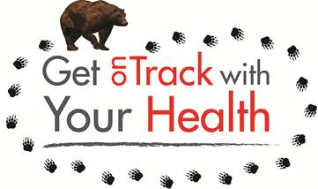Keep track of all days you successfully practice your nutritional behavior between the dates of February 3rd and March 1st. If you are successful for 25 out of 28 days, you become eligible for the prizes.
* Email your score card to [wellness@boyertownasd.org](mailto:wellness@boyertownasd.org) or send to the Ed. Center (Attn to Lucie Bergeyova) during the week of March 2nd.
* Find more information at https://www.boyertownasd.org/Page/5628
* Winners will be announced on 3/11/20.